**Experiment No. 4**

Name: Esha Pal ID No.: VU4F2122047

Sub: BI Lab Div/Batch: A/C

**Aim:** Perform and evaluate Classification Algorithm using any open source tools.

**Steps:**

Step 1 : Download and install Weka.

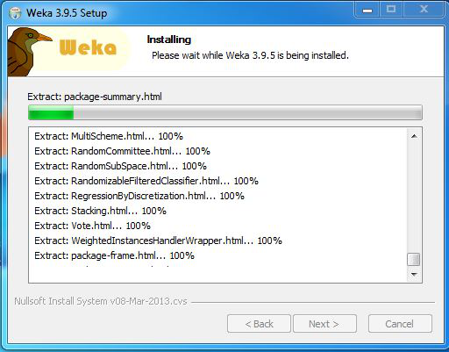

Step 2:Launch Weka Explorer

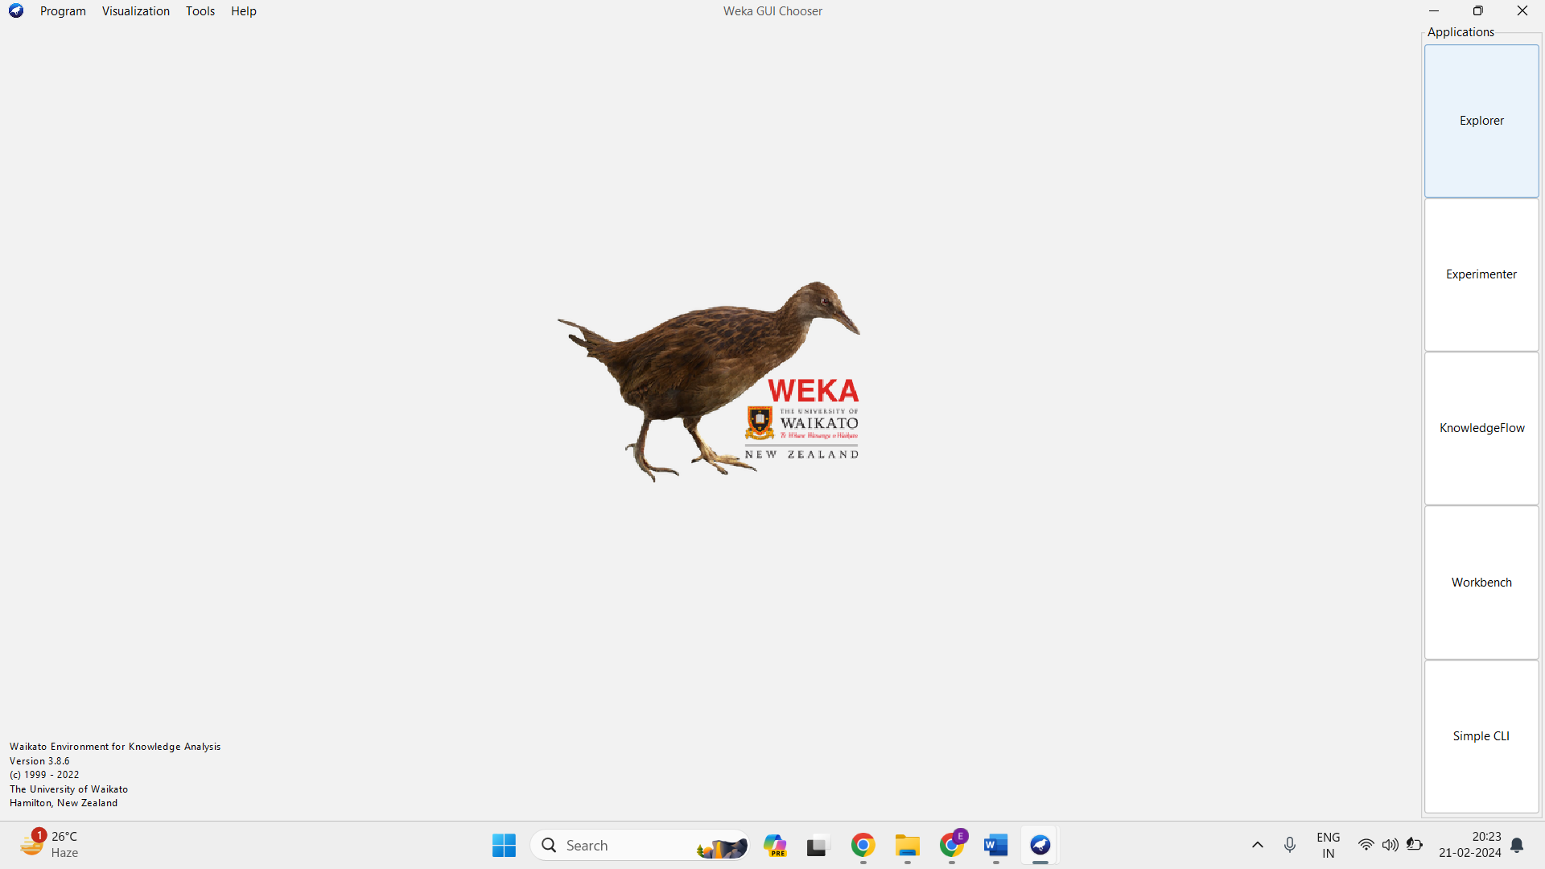

Step 3:Load the Dataset

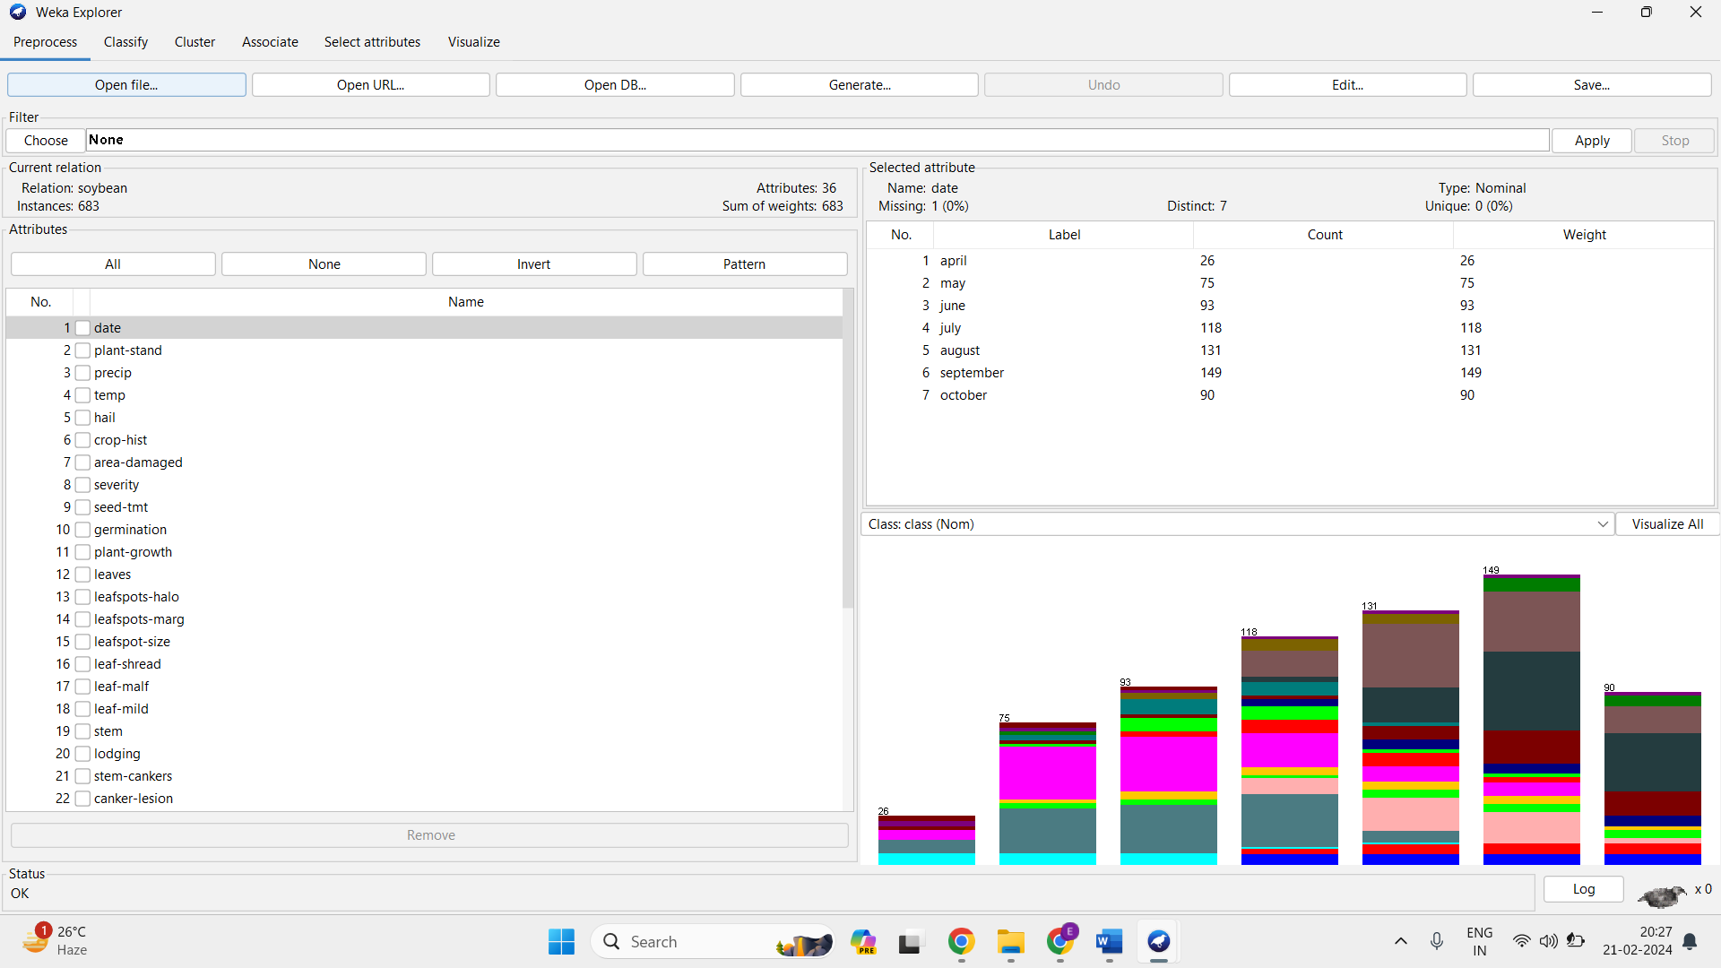

Step 4: Choose Classification Algorithm(J48).

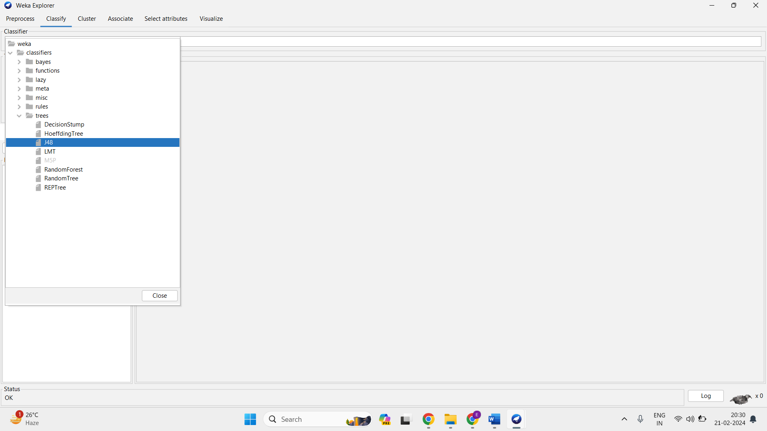

Step 5: Configure Options.

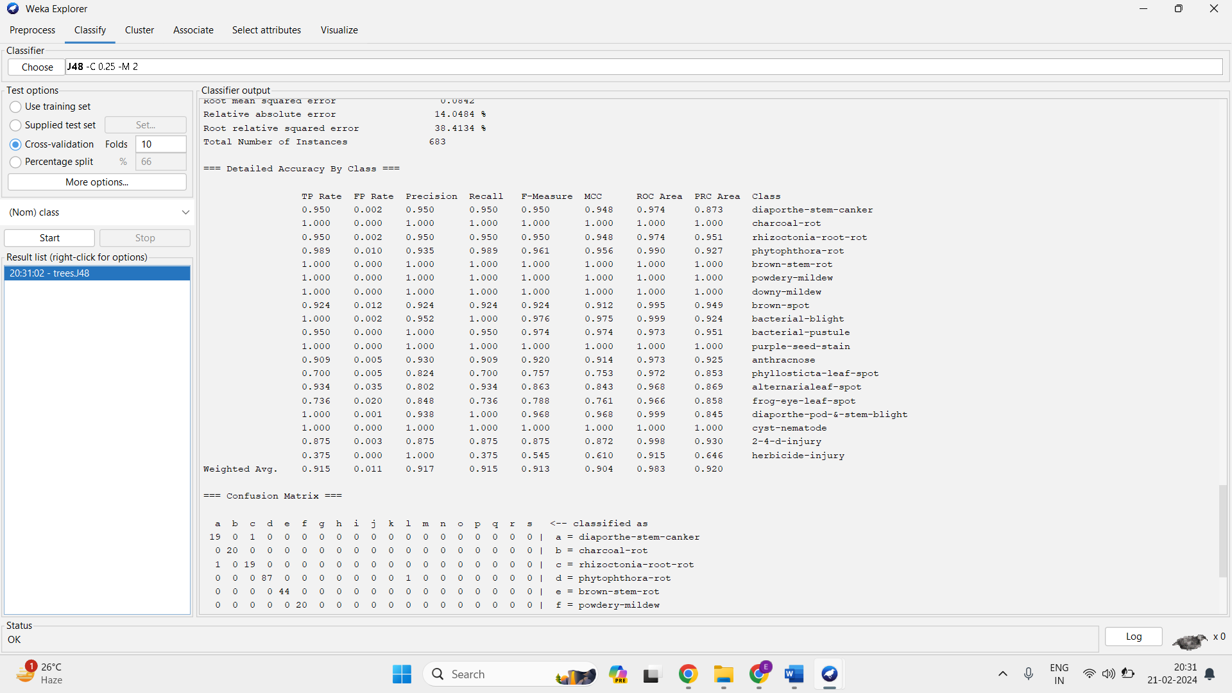

**Conclusion :** Hence we perform and evaluated Classification Algorithm using Weka open-source tool.